Identification of beetles – using dichotomous keys

- Using the dichotomous key below, identify the four beetles in the boxes

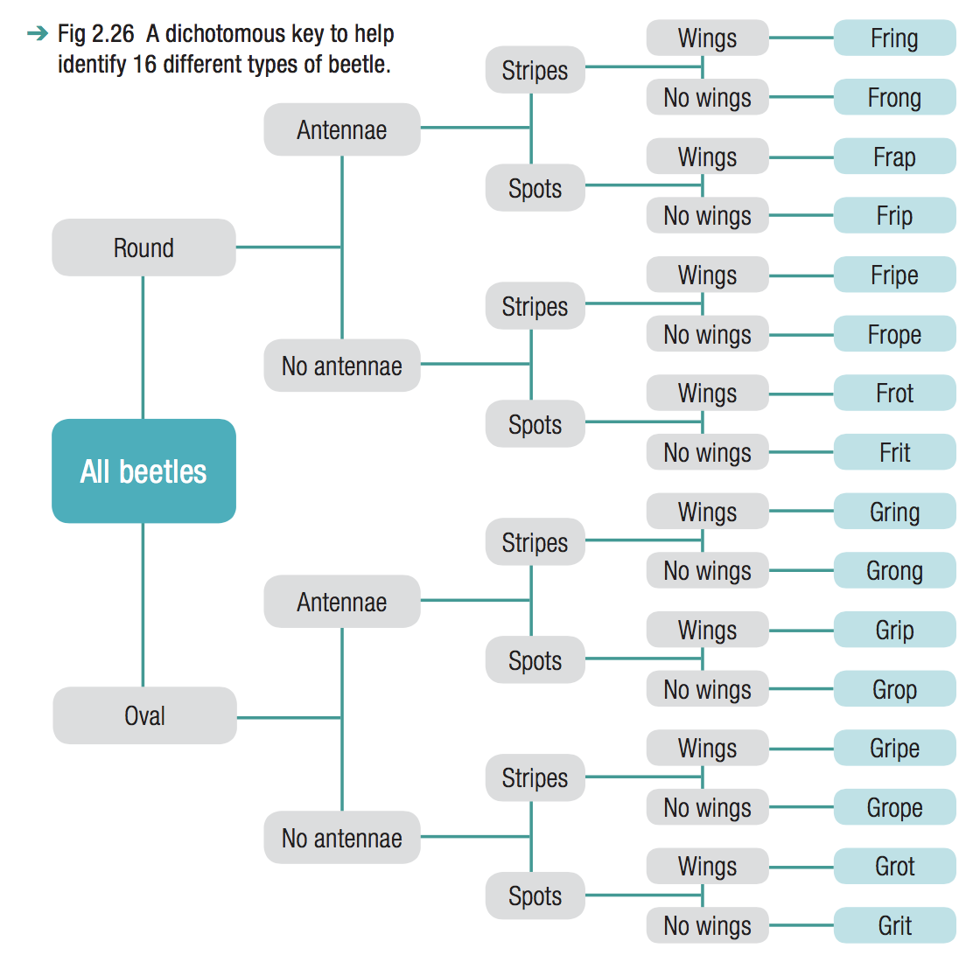
- Find the names of these beetles

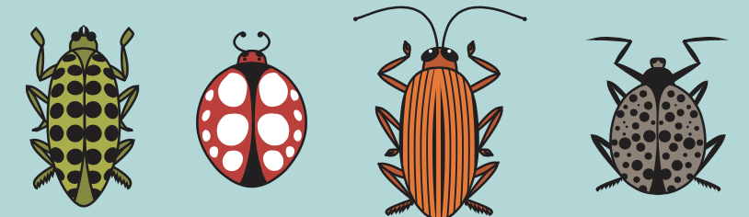

______________

2. Draw a simple sketch of the following beetles using the dichotomous key above
Frope beetle
Frong beetle
Gripe beetle
Gring beetle

